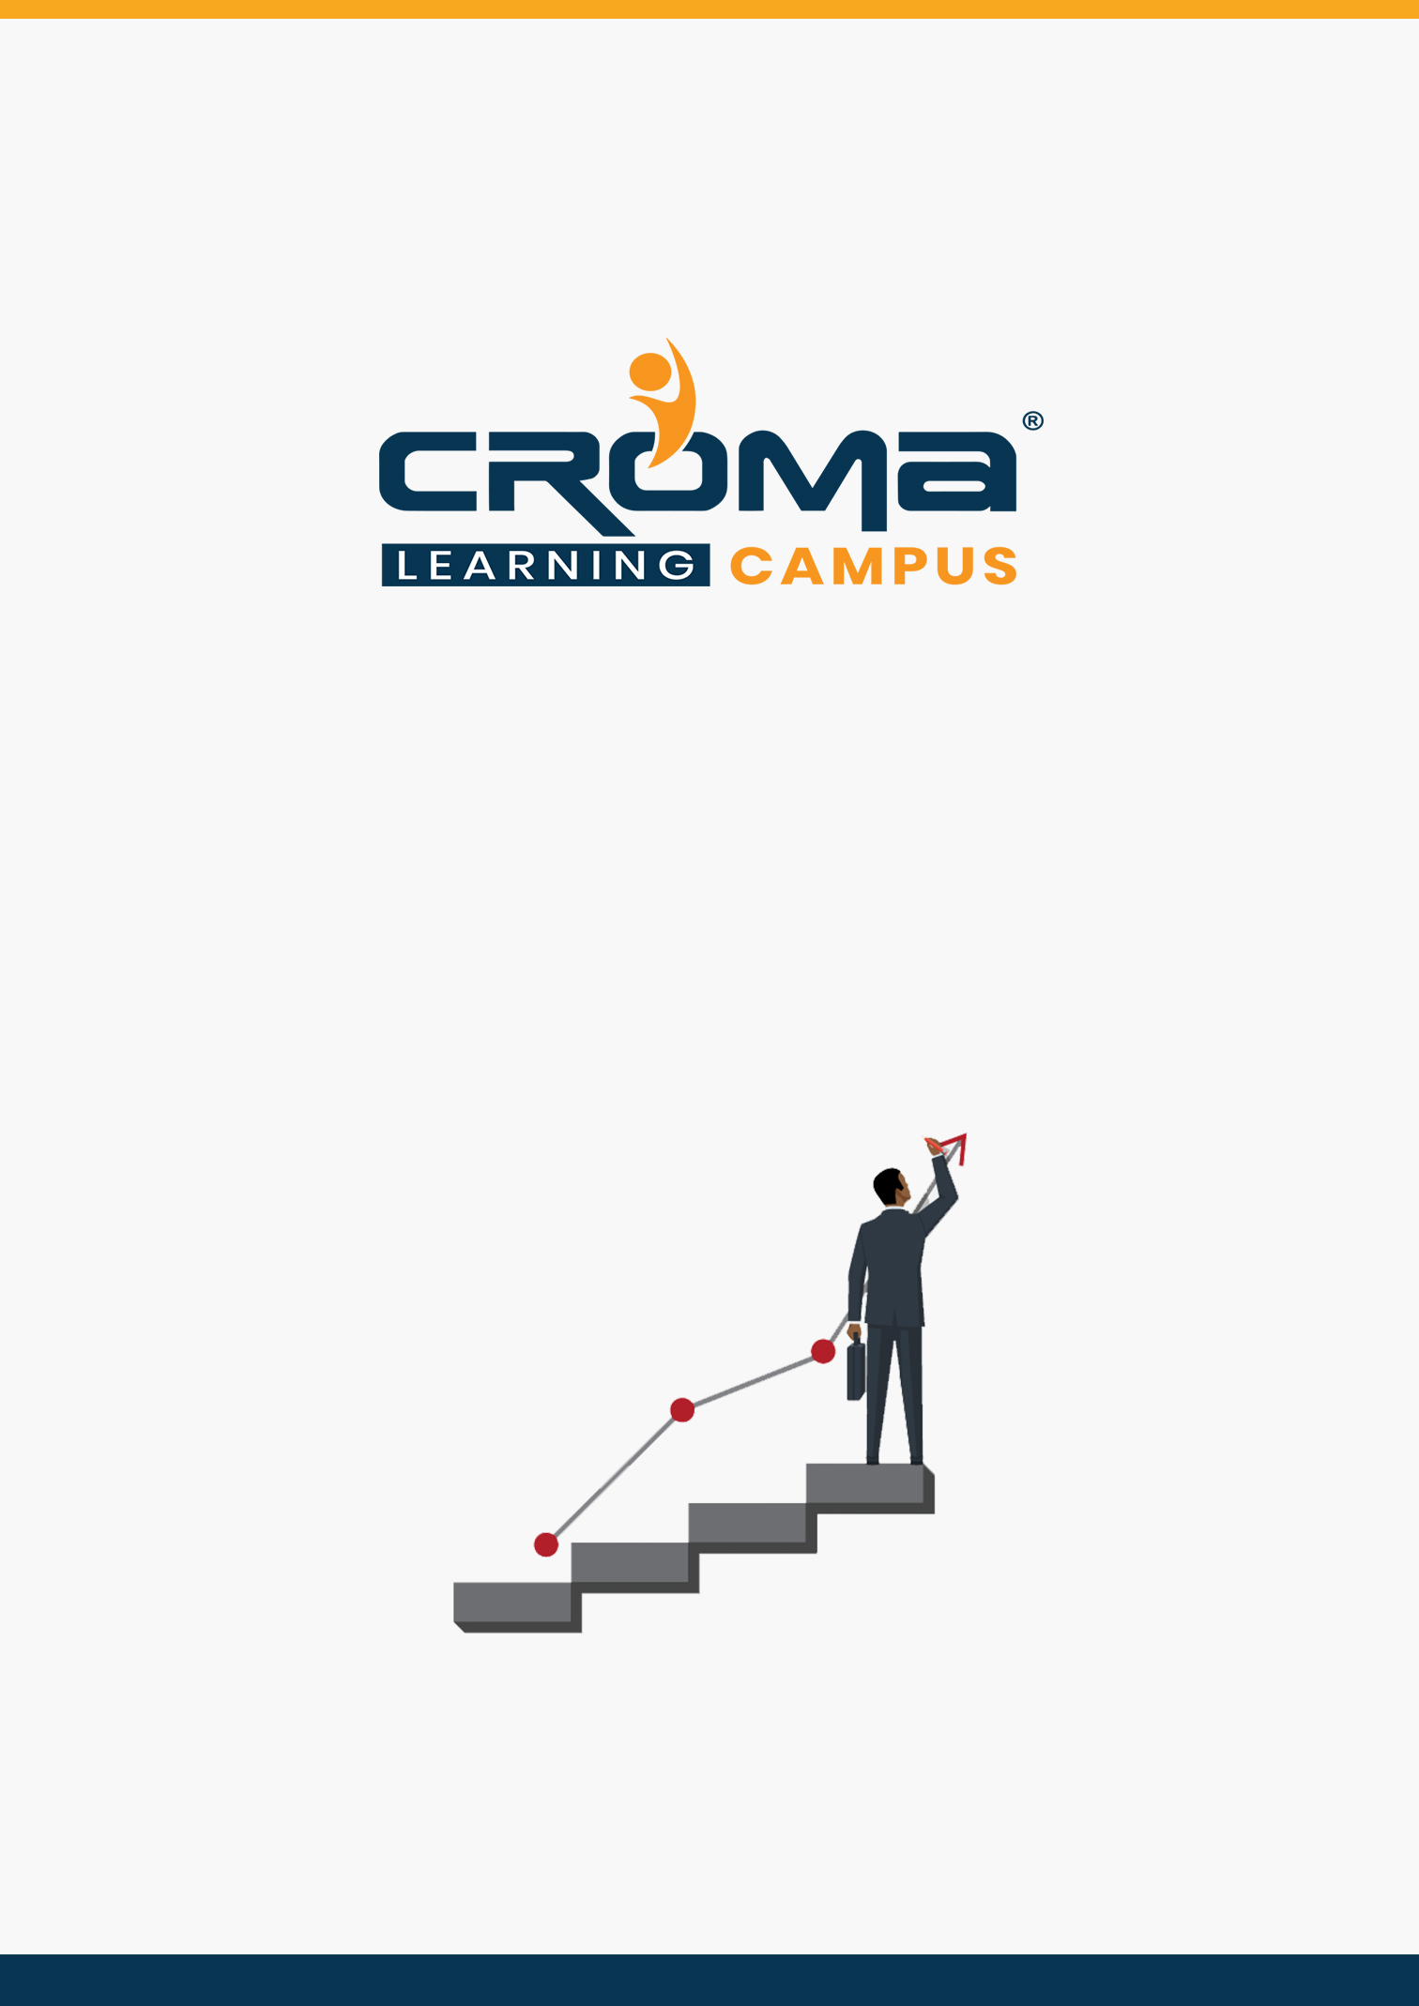

**AWS Certified Sysops Administrator Associate Training Curriculum**

**STRUCTURE**

**www.cromacampus.com | helpdesk@cromacampus.com | +91-120-4155255**

**AWS Certified Sysops Administrator Associate Training Curriculum**

*“Become a AWS Certified Sysops Administrator by joining our comprehensive Training Program”*

**About Croma Campus:**

Croma Campus Training & Development Private Limited is an education platform since 2010 providing rigorous industry-relevant programs designed and delivered in collaboration with world-class faculty and industry.

* Hands-On Live Projects
* Simulation Test Papers
* Industry Cases Studies
* 61,640+ Satisfied Learners
* 140+ Training Courses
* 100% Certification Passing Rate
* Live Instructor Classroom / Online Training
* 100% Placement Assistance

Course Objectives:

* Understand the core concepts of AWS Cloud
* Leverage AWS operations tool to monitor AWS resources
* Perform AWS cli operations
* Rich hands-on labs to understand concepts better
* Understand and Create VPC and auto-scaling
* Ability to deploy and operate EC2, EBS, and ELB service
* Ability to create IAM users, groups, policies, and roles
* Cloud Watch Monitoring

Course Description:

The course is designed based on official certification requirements outlined by AWS Cloud provider for AWS Certified SysOps - Associate. After this Course, you will be able to appear AWS Certified SysOps- Associate. The exam fee is 150 USD with Single attempts at additional cost.

* Gives an edge over other professionals in the same field, in term of pay package.
* All roads are leading to Cloud, and everyone is adopting Cloud computing. Hence, would require Cloud Engineers to drive their journey to cloud
* Helpful for People are trying to transition to Cloud Engineer roles
* Verifies that you are aware of the latest features of Cloud
* The certification helps to speak more confidently about this technology at my company when networking with others.

Certification Details:

* Format: Multiple choice, multiple answer
* Type: Associate
* Delivery Method: Testing center or online proctored exam
* Time: 130 minutes to complete the exam
* Cost: 150 USD (Practice exam: 20 USD)
* Language: Available in English, Japanese, Korean, and Simplified Chinese

**Croma Campus Training Program Deliverables:**

* **Session Recordings** - Original Class Room Voice & Video Recording
* **Training Material** - Soft Copy Handbooks
* **Assignments** | 25+ Hands-on Exercises
* **Test Papers** - We provide **Practice Test** as part of our course to help you prepare for the actual certification exam.
* **Live Case Studies**
* **Live Projects** - Hands-on exercises and Project work. You will work on real time industry-oriented projects and assignments for each module to practice.
* **Key focus on Hands-on exercises and Project work**. You will work on real time industry-oriented projects.
* Faculty with more than **10+ Years of Experience** in the Industry.
* **Technical Resume Designing & Job Assistance:** With more than 100+ Clients across the Globe and we help learners to get a good job in their respective field. We also help learners with resume preparation.
* **Interview Q&A**
* **About Croma Campus Training Certificate:** Croma Campus will provide you with an industry-recognized (Certified by **ISO 9001:2015** & **E-Cell IIT Jodhpur**) course completion certificate which has lifelong validity.
* **How I Unlock my Croma Campus Certificate:** Attend Complete Batch & Submit at least One Completed Project.

Course Content:

Module 1: AWS Technical Essentials

* Overview
* User Sign Up
* Overview Amazon Management Console
* Management Activity and Billing overview
* Amazon Pricing

Module 2: AWS Big Picture

* An overview of AWS
* EC2- An overview
* EBS- An Overview
* Security Group-An Overview
* Elastic IP- An overview
* Cloud Front-An Overview
* S3- An overview
* Glacier- An overview
* IAM – An Overview
* RDS- AN overview

Module 3: Amazon EC2 - Win Server 2012

* Launch Windows server 2012 Instance
* Decrypt Password and download RDP shortcut client
* Connect to the EC2 Windows 2012 instance
* Terminate the Windows server 2012 Instance

Module 4: Amazon EC2 - Security Groups

* Creating Security Groups
* Modify Security Groups
* Delete Security Groups

Module 5: Amazon Elastic Block Store

* Create Standard Volume
* Create and delete snapshots
* Create Provisioned I/o Volume
* Assign volumes to Windows server 2012 and Ubuntu 14.04 server
* Disassociate and Delete volumes

Module 6: Amazon Elastic Load Balancing (ELB)

* Launch Two Ubuntu EC2 Instances- apache web servers with user data
* Edit HTML files to both the servers
* Test your web Servers through internet
* Create Elastic Load Balancer
* Add both the Ubuntu servers to ELB
* Test your Elastic Load Balancer
* Delete your Elastic Load Balancer

Module 7: AWS Route53

* What is Route53?
* Route-53 demo integration with ELB you created (Performed by Instructor only)

Module 8: AWS S3

* AWS S3- Overview and Pricing
* Create Bucket and Folder
* Upload, download, share and delete object
* Delete Bucket

**Module 9: Amazon EC2- Ubuntu 14.04 with user data**

* Launch the EC2 Ubuntu cloud server
* Using User-data of web-server
* Validate user data is executed successfully

**Module 10: Amazon EC2 and EBS System operations**

* EC2- Advanced theory ec2 EBS vs instance store
* EC2- Operations (Status checks)
* EC2 – Creating your own AMI
* EC2 – Launching instance using own AMI
* EC2 – Copy snapshot across region and share across accounts
* EBS – Snapshot
* EBS- Creating volume using snapshot
* EBS – Copy EBS snapshot across region and share across accounts
* EBS - Upgrade volume types
* Security Groups - Create, Edit, and Modify Rules

**Module 11: Disaster recovery and Backup**

* Disaster recovery in AWS
* Backup in AWS
* Recovery in AWS
* AWS services and automated backups
* Storing log files and other backups

**Module 12: Amazon Opsworks**

* AWS Opsworks overview and pricing
* Setup Opsworks
* Get started with sample stack

**Module 13: AWS S3**

* AWS S3- Overview and pricing
* Create Bucket and Folder
* Upload, download, share and delete object
* Delete Bucket
* File Versioning

**Module 14: Amazon Glacier**

* AWS Glacier overview and pricing
* Create life cycle policies for your bucket
* Access data from Glacier
* Setting auto delete to your data from s3 based on rules

**Module 15: Auto Scaling and Bootstrapping**

* Overview of Auto-scaling
* ELB: Configuring the Elastic Load Balancer for Auto-scaling group
* Configuring the AMI for Our Web Application
* Auto Scaling and Bootstrapping
* Scale out VM’s though stress test
* Scaling VM ‘s based on low utilization
* Troubleshooting auto-scaling issues

**Module 16: AWS - IAM (Identity and Access Management)**

* What is IAM? – A comprehensive introduction
* AWS federation with Active directory- Theory only
* Getting started with IAMs
* IAM user- groups
  + Creating a user and group
  + Adding a user to the group
  + Password policy setup for users
  + Attaching policy to users
  + Enabling dual /Multifactor authentication to the users
* IAM Roles
  + Creating a role
  + Launching a EC2 instance using a S3 full access role
  + Deleting a role
* Security Token service
* Security on AWS
* AWS and IT audits

**Module 17: AWS CLI**

* Working with the AWS CLI
* Launch instance with s3 and ec2 full access
* Configure AWS cli client
* Create a security group using cli
* Create a key pair using cli
* Launch an ec2 instance using cli
* Stop an ec2 instance using cli
* Terminate an ec2 instance using cli
* Create an s3 bucket using cli
* Upload and download an object from your local machine to s3 through cli
* List buckets through cli
* Delete buckets through cli

**Module 18: AWS - Web App and RDS**

* RDS - An Overview
* RDS – Read Replica
* RDS- Multi AZ failover
* RDS snapshots
  + Create a RDS instance
  + Connecting to an RDS instance
  + Creating a RDS snapshots and restoring snapshot
  + Deleting RDS snapshots
* Deploy Web application in Amazon Ec2 (media wiki)
* Connect your Media wiki web application with RDS instances securely
* Make media wiki available on public URL for user sign up and write knowledge wiki
  + Deleting RDS instance

**Module 19: AWS Route 53 (Live Demo by Instructor)**

* Route 53 - routing options
* Simple routing – Hands-on lab
* weighted routing policy lab
* latency based routing lab
* Geolocation based routing lab
* failover routing lab

**Module 20: AWS - Virtual Private Cloud (VPC)**

* What is VPC? – A comprehensive introduction
* Networking bottlenecks
* Understanding VPC configurations
  + VPC with single public subnet
  + VPC with public and private subnet
  + VPC Peering
  + Access control List
* Configuring VPC Instances (Hands on lab by students)
  + Creating a VPC
  + Subnets
  + Internet Gateway
  + Routing
  + Configuring a NAT Gateway
  + Creating security groups
  + Launching instances in public and private subnets
* NAT vs Bastions
* VPC Flow Logs
* VPC clean up

**Module 21: AWS Cloud Formation**

* Infrastructure as Code using Cloud Formation
* Cloud formation – Create a new stack
* Create and deploy sample template in JSON format
* Use existing templates and deploy

**Module 22: Monitoring in the Cloud**

* Cloud Watch Introduction
* EC2 Status Troubleshooting
* Create A Cloud Watch Role
* Monitoring EC2 with Custom Metrics
* Monitoring EBS
* Monitoring RDS
* Monitoring ELB
* Monitoring Elastic Cache
* Centralized Monitoring Servers
* Consolidated Billing
* Billing & Alerts
* Cost optimization

**Module 23: Placement Guide**

* Tips to clear an Interview
* Common Interview questions and answers
* AWS Cloud Sysops Interview Questions and Answers
* Resume Building Guide
* Attempt for AWS Cloud Sysops Associate Global Certification Exam
* Earn Credentials and Start applying for Jobs